|  |
| --- |
|  |
| CA Charity Finder |
|  |
| Application Proposal |

July 30, 2015

Harman Grewal

hsgrewal8@myseneca.ca

CA Charity Finder

Application Proposal

## Executive Summary

CA Charity Finder is an application that provides users with access to a list of all Canadian charities. Users can search for a charity based on various fields, and help them find the charity that they would like to help with. Once a user selects a charity from the database, it will provide them with information like the founder, location, address, email, and website.

## Why an Application?

Firstly there is no user friendly database available for users to access the vast amount of charities that Canada has to offer. With the ability to search for charities based on name, location, and various other fields, users can ensure they find charities that they are interested in.

## Application Features

* Search database for specific charity (Search by name, location, etc)
* Display charity information (Name, province, etc)
* Link to website
* Email charity
* Bookmark charities

## User Market

* Businesses who run charity drives
* Schools
* Detention/Rehab centers
* Celebrities and other people of notoriety

## Common Use

The most common use of this application would be for people who may hear about disasters or charities on the news and radio. This application would allow them to search and possibly donate to the charity if they would like. Imagine if you were business professional who live life on a very tight schedule, it would be hard to remember if a specific charity that piqued your interest was mentioned as you were traveling to work. With this application, you can instantly get basic information of the charity and be linked to their website.

## Mock-up Views

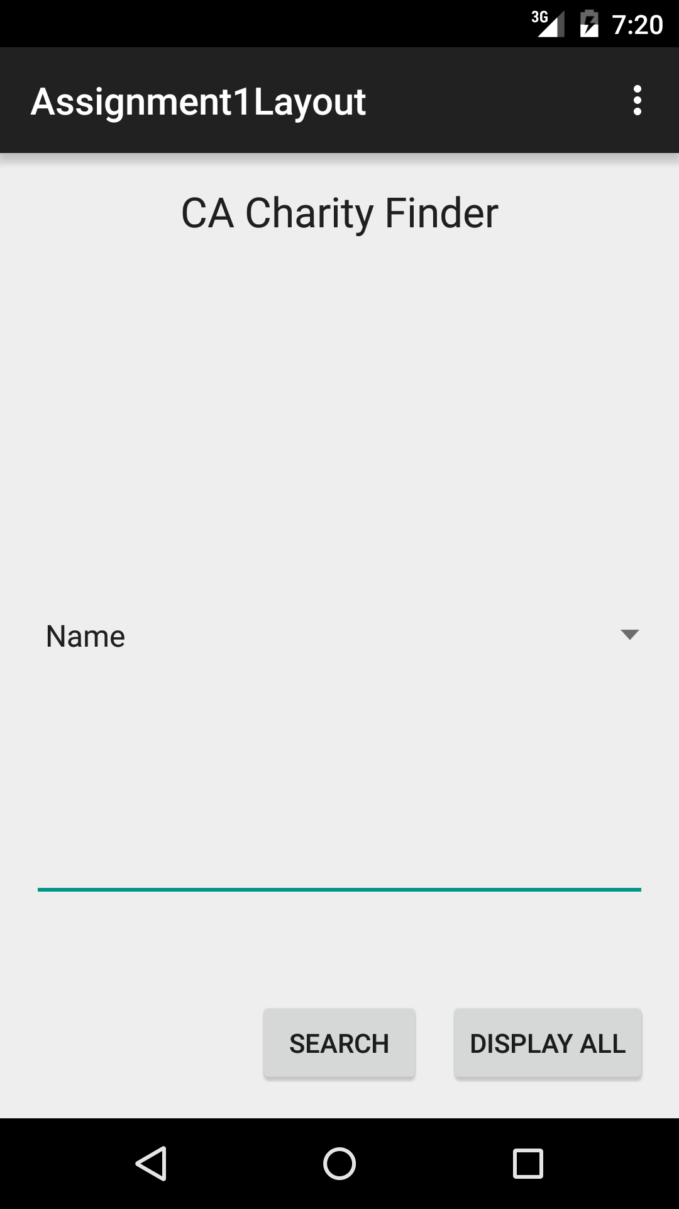

Figure : Main page, allows for searching

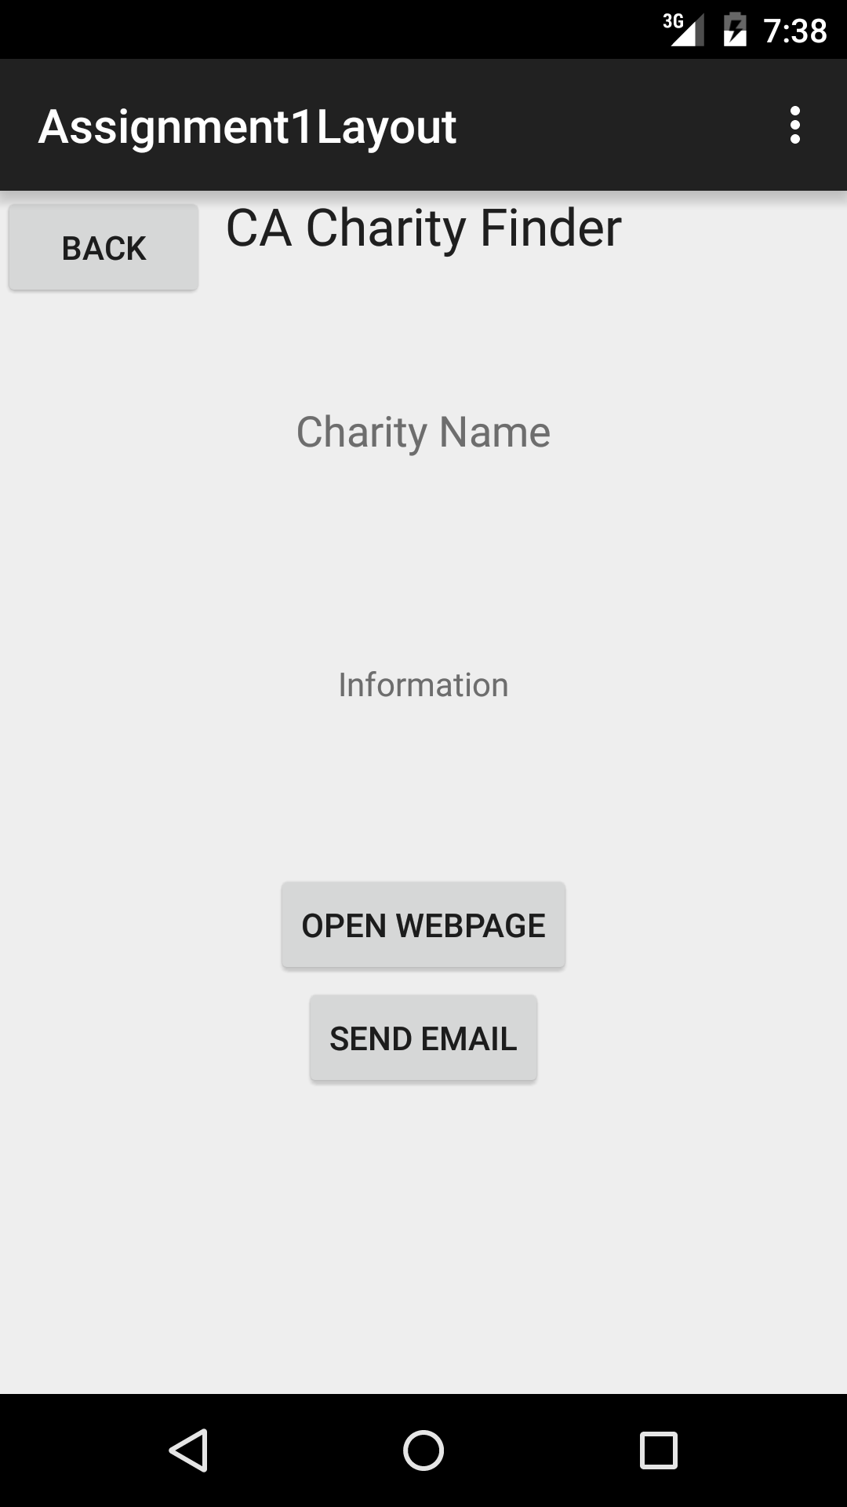

Figure : Page when a Charity is selected

## C:\Users\Harman\Pictures\assig1-2.png

Figure : Search query page

## Timeline

Final Deadline: To be announced

|  |  |
| --- | --- |
| **Task** | **Date** |
| Proposal completed | July 30, 2015 |
| Production Ready Layouts | August 5, 2015 |
| Database Queries | August 8, 2015 |
| Charity Page populated | August 10, 2015 |
| Website linking and email capabilities | August 12,2015 |
| Bookmark list | August 14, 2015 |